*File Listener*

*Create a Service Package:*

*Go to 🡪 Integration Resources-> Service Package*

***Short Desc****: BOA Service forListeners,****SerPackName****:BOAServiceListeners*

*Uncheck Requires Authentication and provide the AcessGroup*

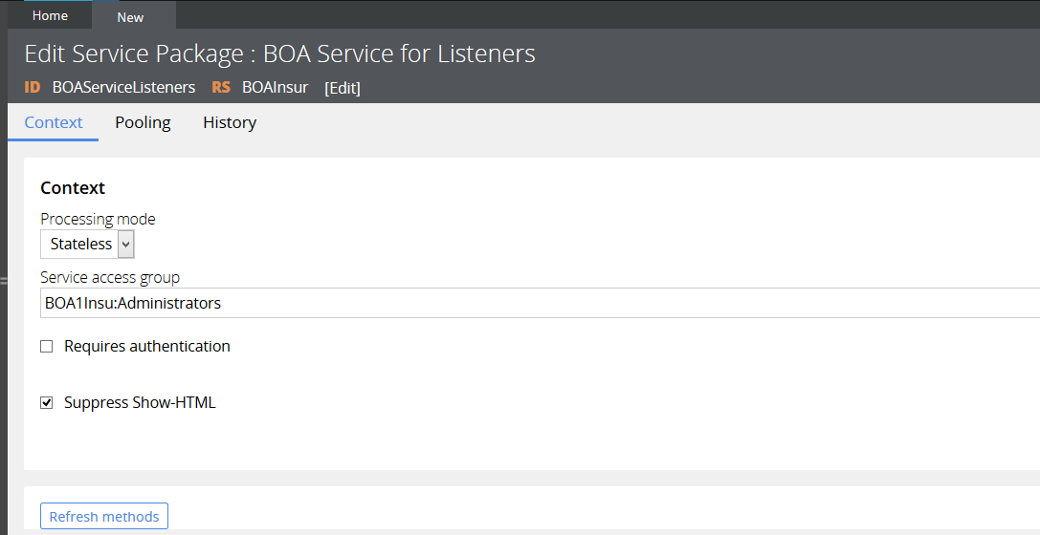

*Go to 🡪 Integration Services-> Service File*

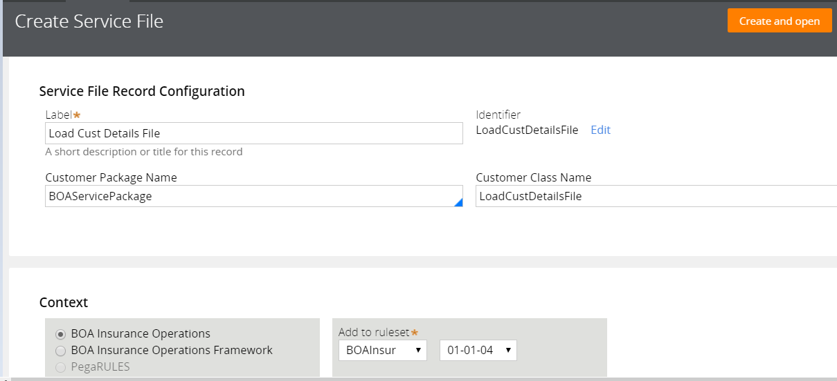

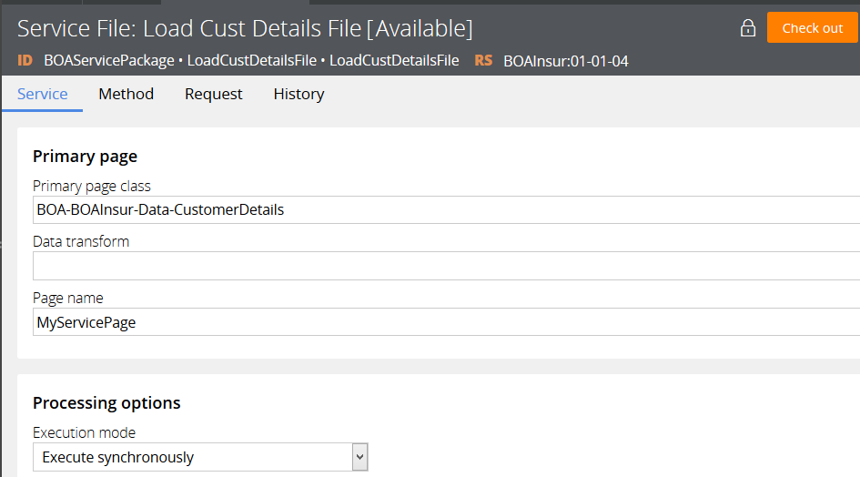

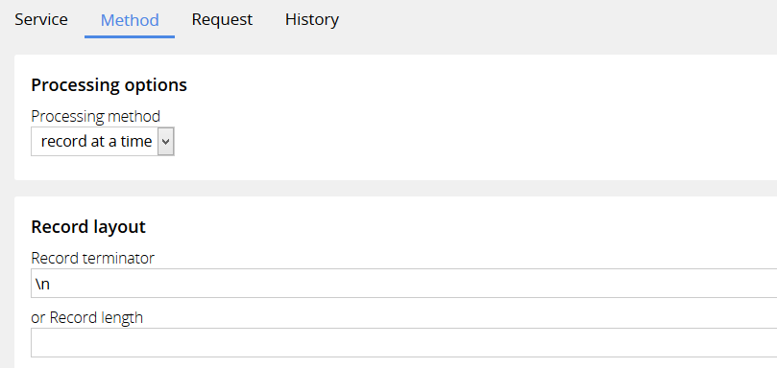

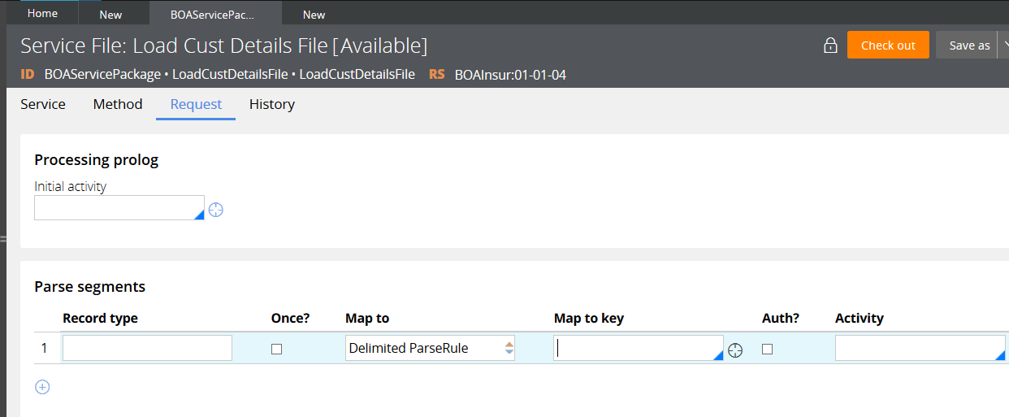

*Click on Map to Key Crosshair icon to create* ***Parse Delimited Rule*** *after creating select from dropdown and Create an activity to save the clipboard page.*

***Label****: Map Cust Details* ***Record Type****: MapToClipboard*

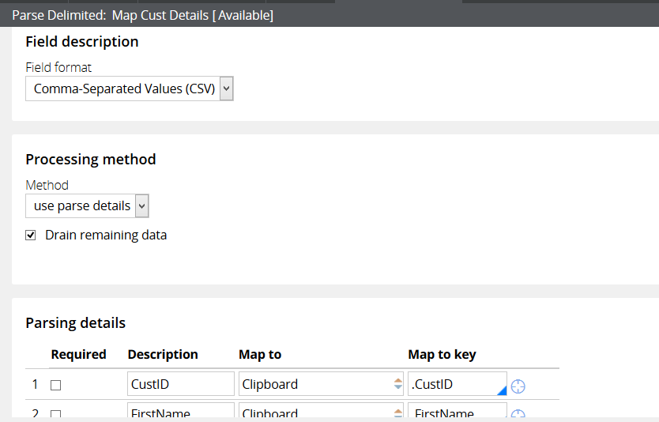

*FieldFormat: CSV , Select all the required columns from Parsing Details*

*Create An Activity Called SaveCustDetails and call in the Service File Rule*

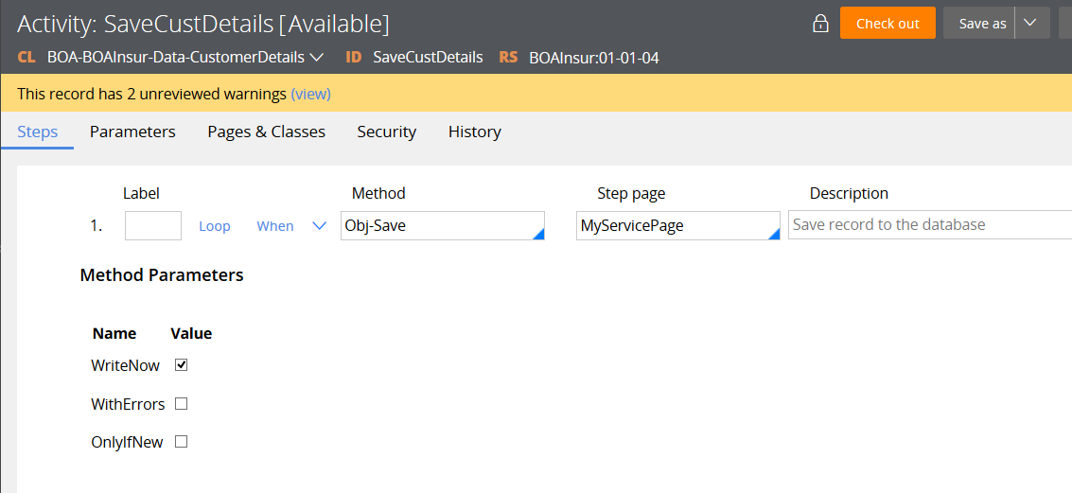

*Create a File Listener rule from the integration resources-> FileListener*

*ShortDesc: Load Cust File Listener Name: BOALoadCustFile*

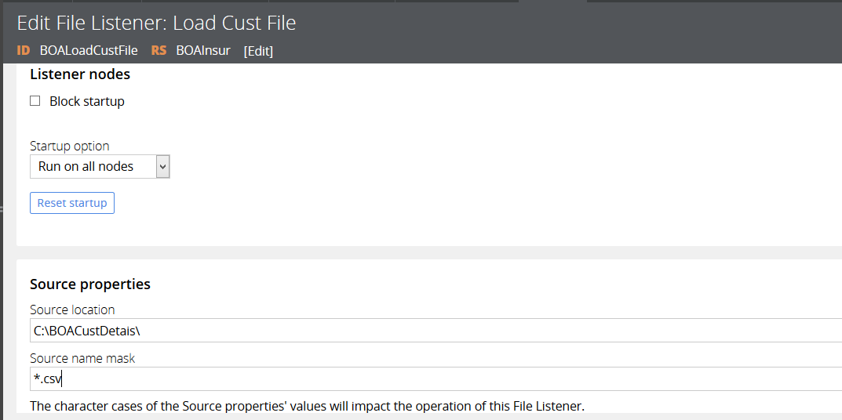

*Select the source location ,source mask ( *.CSV) and servicePackagedetails as specified below.*

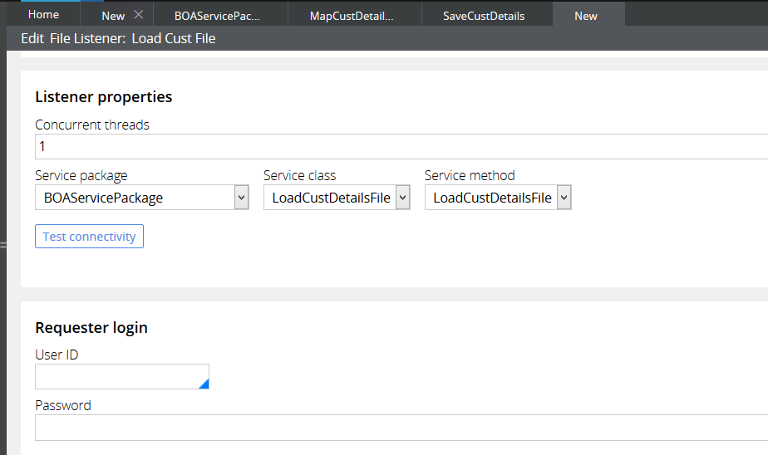

*Save and click on test connectivity toknow the status ( Should be good)*

*Now configure the Listener on SMA to start the processing ☺*

*DesignerStudio-> System->Operations -> SMA*

*Listener Management*

*Select the Listener from the dropdown and Click on start*